Dr Alfons Böcker, 17/05/1926 – 18/07/1985
A short biography by Mathilde & Klaus Boecker
Last year, on my first walk to the Directing Staff office in Seaford House, I spotted on a mahogany board in the hall of the second floor: Dr. A. Böcker, German Foreign Service, the name of my grandfather whom sadly I never had a chance to meet due to his untimely death 13 years before I was born. Dr. Alfons Böcker, or just ‘Alf’ as he liked to call himself, was a Member of the course of 1970 at the Imperial Defence College (IDC), which was renamed Royal College of Defence Studies in that same year. Though I never had the chance to meet him, my father, Klaus, has shared countless stories that have kept his memory alive. We wrote this piece for SUMMIT together.

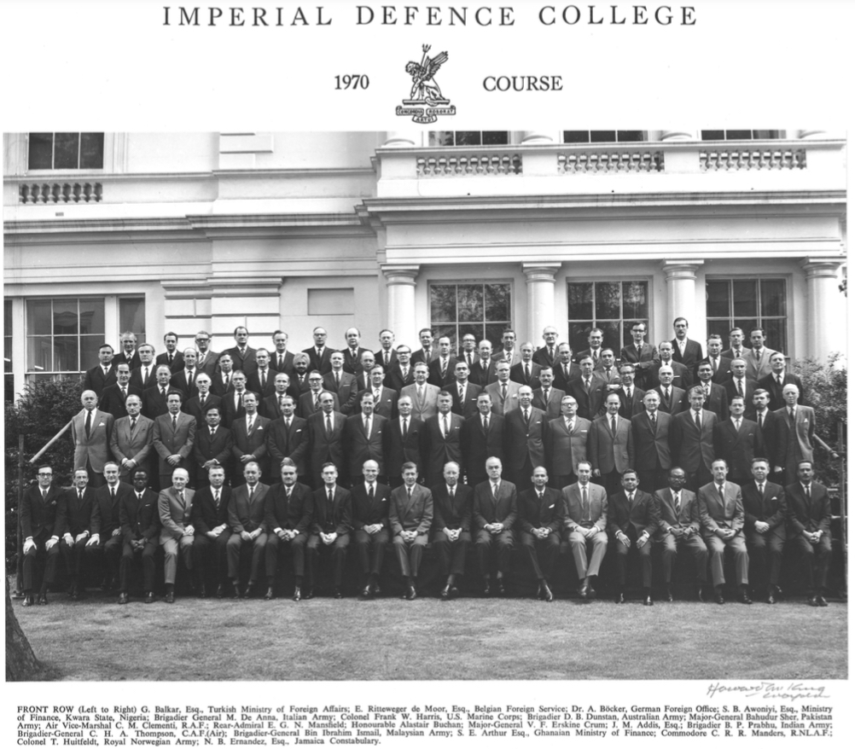
Alf was born in 1926 in Lünen, a coal-mining town in the Ruhr Region of western Germany. His father, Carl-Heinrich Böcker, a graduate mining engineer from Bochum University, was revered throughout the 1920s and early 30s for his contributions to significantly reducing the previously shockingly high number of mining accidents in the district. Additionally, he served as President of the local WWI Veterans Association Stahlhelm, having ‘fought valiantly and victoriously for the Kaiser at Tannenberg and the Masurian Lakes’. However, after losing his only brother Hermann in that brutal war, he had turned away from German nationalism to strict Catholicism for his guiding principles in life. Thus, it came as no surprise that he was sacked by the Nazis as safety inspector of the local coal mines and removed from the Civil Service only months after they seized power in 1933 for refusing to amalgamate his local Stahlhelm section, which he perceived to be honourable, into the new Nazi Frontkämpfer Bund. His membership in the Stahlhelm was terminated, and he was demoted to the rank of mine-electrician and compelled to work ‘down in the pits’ for the following twelve years, until his eventual rehabilitation by the British Administration in 1945 and appointment as general manager of the highly productive local coal mine, a position he held until his death in 1953.
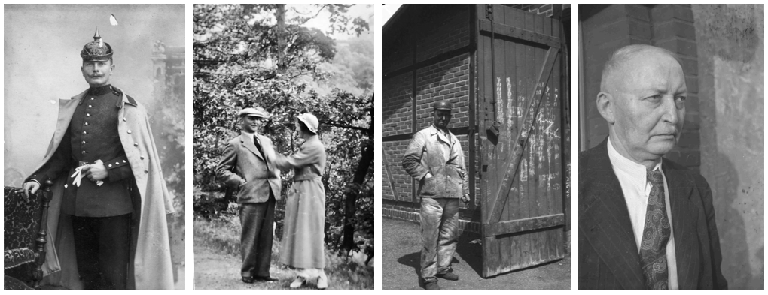
Carl-Heinrich Böcker, 1883-1953
Alf’s mother, Huberta ‘Hubertine’ Böcker, née Pilgram, only just five feet tall but all the more temperamental for it, was a vociferous pacifist and Catholic, having lost her father and three brothers in WWI and the aftermath. She was detained, brought before Nazi judges, and cautioned or fined on at least six documented occasions for ‘offences’ such as mocking the Führer’s birthday parade in public, making derogatory remarks about official Nazi newspapers (Völkischer Beobachter & Der Stürmer), buying at the Jewish butcher’s despite the boycott, failing to enrol her son, Alf in the Hitler Youth organisation, feeding forced labourers during wartime, and in one instance even accused of sabotage after deliberately tipping over a trolley of lightbulbs in protest over the 12-hour factory shifts she was forced to work in the final years of WWII.
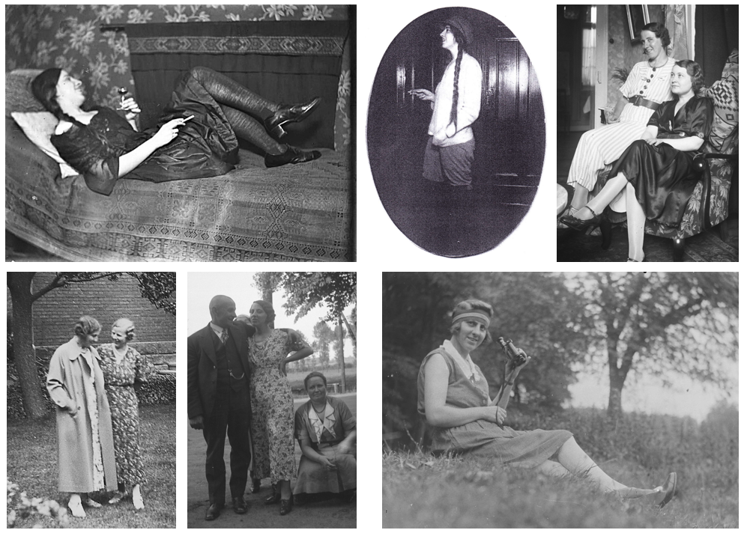
Huberta ‚Hubertine‘ Wilhelmine Böcker, née Pilgram; 1897-1989
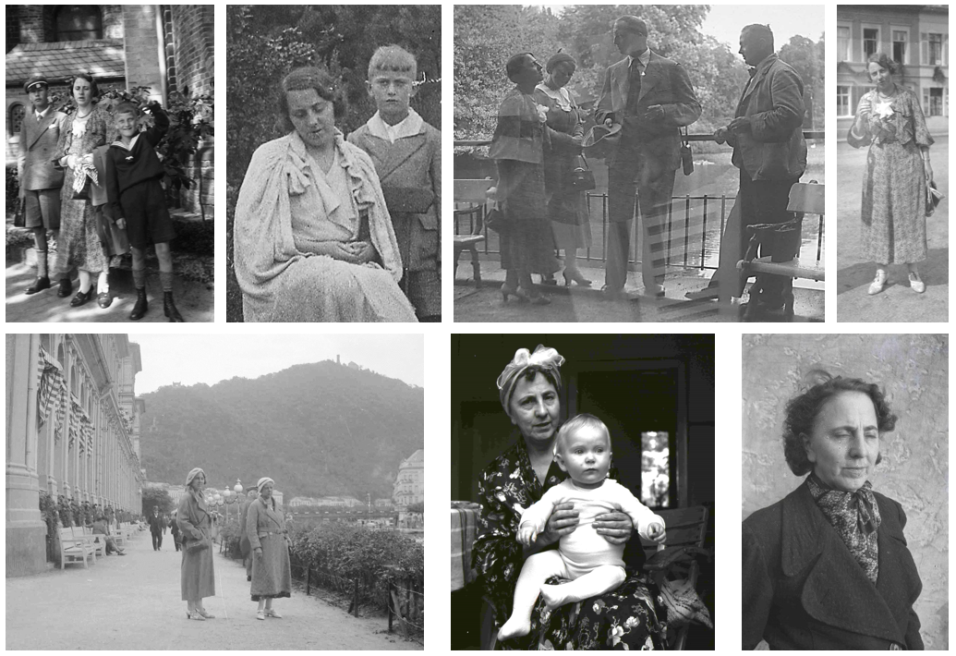
Hubertine, as mother and later, grandmother
Alf was born on May 17th, 1926 and was a healthy and very alert young boy. He attended the local primary school and was enrolled in the Catholic Youth, which was purposefully dissolved three years after the Nazis seized power. Henceforth, Huberta used every excuse she could find to keep young Alf away from the Hitler Youth. Young Alf was sent to a seaside sanatorium for a month ‘to cure his asthma caused by the appalling air quality’ to prevent him from ‘being infected with Nazi atheism and venom at one of their summer camps’. Or the fact that one of his legs was allegedly 1.5cm shorter than the other served to regularly excuse him away from Nazi sports activities or rallies. In consequence, Alf learnt to heed absolute ‘political conformity’ when anywhere outside the family home from a very early age.
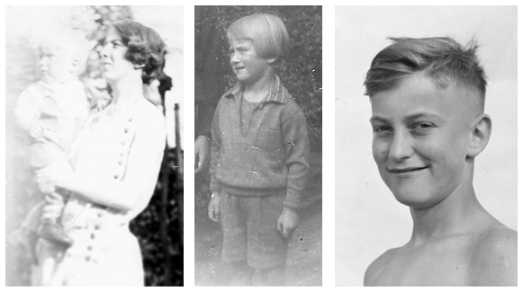
Despite the Böcker family’s increasing predicament from 1933 onwards, Alf maintained solid non-political friendships with his peers, went on lengthy bicycle tours across ‘the Reich’, and excelled in swimming, sketching, and building shortwave radios, a hobby that gave him illicit contact with the outside world. Alf dreamed of travelling to America to meet the relatives of his mother’s, who had emigrated in the 1880s and struck it rich in Chicago and St. Louis but frustratingly, the only foreign country his parents ever took him to was Holland, approx. 40 miles from their home. To pre-empt avoidable antagonism for his lack of allegiance to the Hitler Youth movement, Alf would wear his silver swimming proficiency badge on his lapel where others wore their HJ-badge, thus often escaping notice.
Aged 16, Alf and his classmates were compelled to reside in makeshift barracks during the school term, taking their lessons in open air and operating the flak whenever the sirens warned of imminent raids of US or British bombers. Across the year the downed merely one US bomber, the crew of which managed to bail out. Alf of course had no idea that one of the planes which passed by unscathed would kill the mother and niece of Eva, the woman he would meet and marry 10 years after the war.
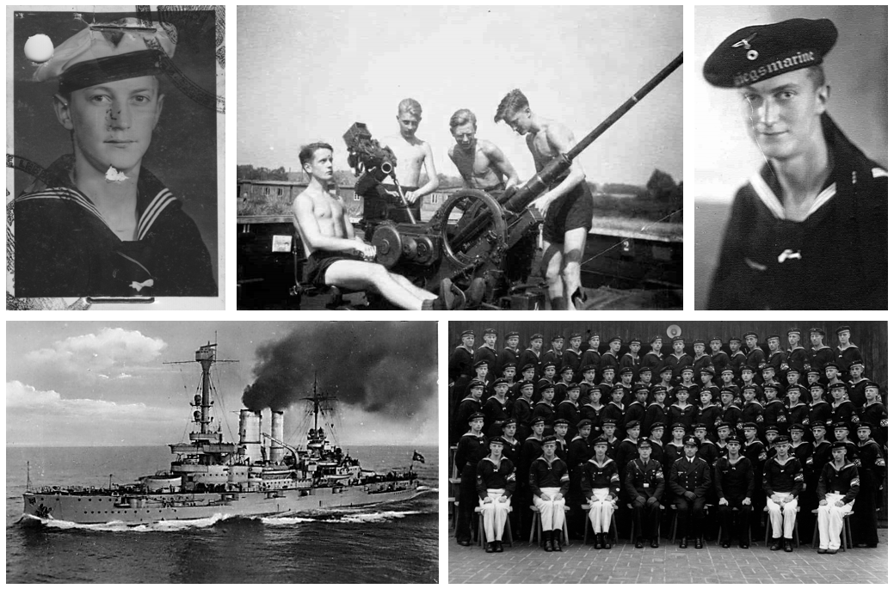
Alf’s WWII experience; 1944-45
After completing his final school year, Alf aged 17 was conscripted. Having volunteered as a naval cadet he was accepted into the navy. (NB. His father had monitored official casualty rates throughout the war concluding that the safest place to be was at sea provided you were too tall to be assigned to a U-Boot, which was the case for young Alf).
Alf served for a few months as a trainee signaller and gunner on the battleship ‘Schlesien’. Most of that time was spent in German and Scandinavian ports fending off air attacks. When the Schlesien ventured out to escort convoys of refugees from East Prussia and Silesia, she struck a mine and sank. (Only) two of the crew perished. Alf and all the others were picked up by nearby ships in the convoy. However, apparently only two days later, Alf’s new ship was attacked by Russian planes harrowing the convoy, and sunk, killing an unknown number of crew and passengers. Again, Alf was lucky, picked up by a nearby German ship and dropped off on dry land. Alf never disclosed any details, but according to my father, Klaus you could sense that the witnessing of Russian air-attacks on German refugee ships had left a deep scar. Back at his naval base, Alf learnt that his best friend Max had died in action.
When the war finally ended, 18-year-old Alf found himself in a British prisoner of war camp in the north of Germany. For 6 weeks he assisted the camp’s administration in registering German and other Axis prisoners. Subsequently, he was discharged on account of his young age and cooperation, and in the absence of functioning civilian transportation, walked about 300 miles back to his hometown.
There he helped with clearing of bombed-out homes until the local grammar school reopened, and he could retake his final upper school exams. (NB: war-time Nazi-curriculum graduations had been invalidated by the administration of the British Sector).
After successfully completing his Abitur, despite having applied for and received a place at Hanover University to study engineering/architecture, his teenage career aspiration, in January 1945 from aboard his ship he enrolled at Würzburg University to study Law. This he did on advice of the British administration, which pointed out that ‘the few young Germans without Nazi-legacy should constitute the foundation of the defeated nation’s future Civil Service’.
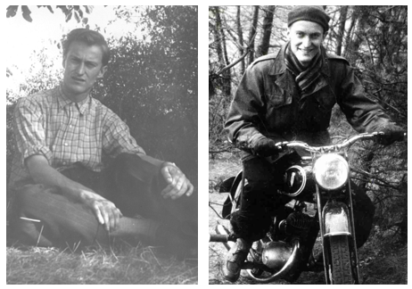
Alf as a student
Alf’s post-war university years were by his own accounts somewhat dire. He resided with a friend in various sheds and remains of derelict town houses. Food was scarce and relied partly on parcels from home.
After university, Alf served his Referendiat term at as a junior prosecutor at the regional Courts in Hagen, Westphalia. During this period, Alf focussed a great deal on courting his wife-to-be, Eva König, and on the art of motorcycle maintenance (though spare parts were severely lacking).
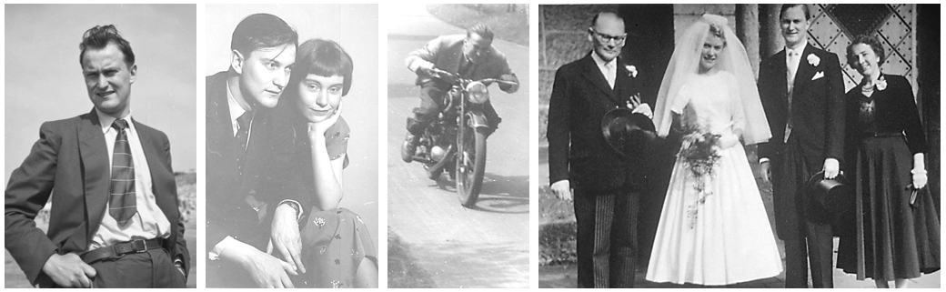
Alf & Eva; 1955 and 1956
Around the time of his marriage, Alf joined the Oberstes Rückerstattungsgericht (the Supreme Court for the Restitution of Jewish assets) in Herford/Germany, where he was in fact the sole German state attorney among predominantly British/Jewish lawyers. The cases were all depressing, but during the years in Hagen & Herford, three of Alf & Eva’s four children (Judith, Klaus, & Christian) were born. He worked at the ORG until the court was dissolved in 1962 due to the low volume of new cases, moving on to join the German Foreign Office after a fast track one year training course. During this period, Alf also successfully submitted and defended his Doctorate in Law thesis at Münster University.
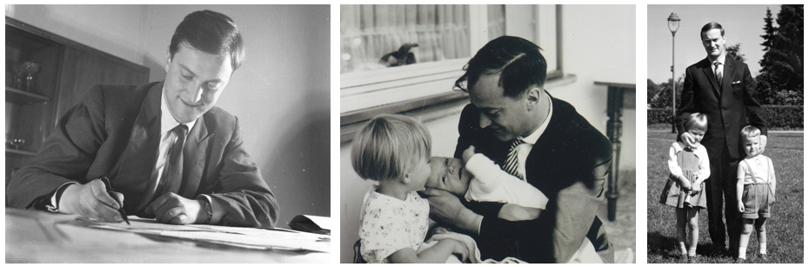
His first posting as a young diplomat took him to Iraq. While the time there initially passed peacefully and without major issues, Alf’s term in Bagdad ended abruptly in June 1963 when the German Embassy was attacked by a stone-throwing mob, furious at the news that the Federal Republic of West Germany had awarded a sum of 1.1 billion Deutsche Mark to Israel as a general reparation payment to cover all illegal damage to the estates of perished German Jews, who could no longer claim themselves. To prevent the ransacking of the embassy building by the mob, Alf took the shrewd decision to immediately sublet the property to the French Embassy, allowing him to hoist the Tricolore, which adequately confused the protesters and induced their dispersal.
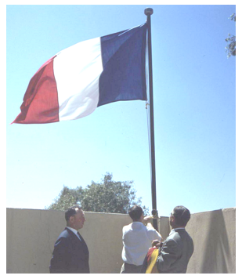
Rooftop of the German Embassy, Bagdad. Alf hoists the French flag; June, 1965
The German embassy staff were given only three days to leave the country. So as to not have to leave behind his precious Ford Taunus automobile, Alf put the family on a plane and then drove his car, accompanied by his nearly 6-year-old son, to Beirut, from their shipping the car to Venice, and then driving back to Germany.
Alf’s second posting took him to Aden, as Consul for the Protectorate of Southern Arabia and Oman. The British were beginning to move out and the local ‘liberation factions’, the NLF & FLOSY were targeting the British Forces & their families, as well as look-alikes, such as Alf & his family. Nevertheless, in close cooperation with the British High Commission, Alf managed to do a few worthwhile things: help with the construction of roads and provide engineering and medicine/pharmacy scholarships to young Yemenis. He also initially found plenty of time to indulge in his favourite pastime, sailing, winning several trophies and serving as Vice Commodore of Aden’s predominantly British Yacht Club. However, when the Labour government under Harold Wilson decided to expedite the British withdrawal things turned rough. After the assassination of one of Alf’s visiting close friends by a terrorist sniper and the evacuation of his two sons to England (wife and daughters had remained in Europe after the Summer holidays, due to the increasingly dangerous situation in Aden), Alf was assailed by armed ‘revolutionaries’ in his Ambassador’s residence. He managed to convince the bandits in broken Arabic that the keys to the embassy cars were with the local driver. However, his two visitors were robbed of all their money and travel documents.
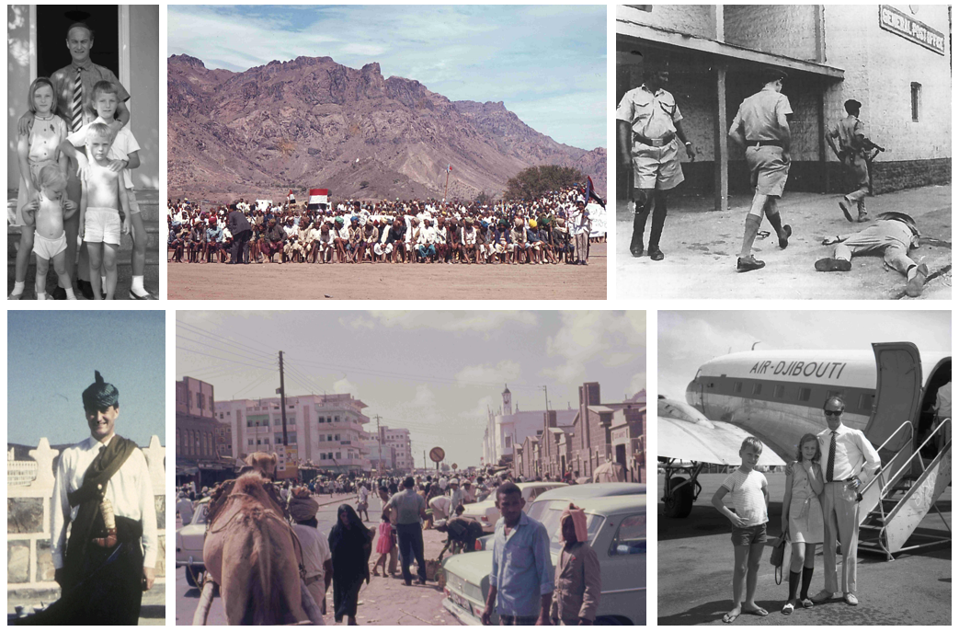
After the independence, the situation in Aden calmed down initially, so the Böcker family was able to return and resume activities there, though the British schools had all disappeared and quality of life deteriorated rapidly. In 1969, the new short-lived government installed by the British on their departure was ousted and replaced by a Revolutionary Committee, which vowed to cooperate closely with the USSR and East Germany, so West Germany broke off political relations, and again Alf was required to leave the country abruptly, within three days. Just before his departure, Alf was accused by the government of the ‘People’s Republic’ of having smuggled two German women and their respective children out of the country in cardboard boxes with the ‘regrettable support’ of British Embassy staff. The official complaint of the Yemeni government states that pending further investigation Alf has forfeited his right to be accredited as a foreign diplomat in the country. Paradoxically, the German Foreign office issued an official warning to Alf, only to award him the Bundesverdienstkreuz on his subsequent return to Bonn.
After a short spell in Bonn, Dr Alf was assigned to participate in a strategic training programme at the Imperial Defence College (IDC), now the Royal College of Defence Studies (RCDS) in Belgravia, London. Alf was thrilled! The course allowed him to greatly deepen his understanding of defence, culminating in his final essay on ‘Soviet Sea Power in the Indian Ocean’. Alf truly enjoyed his year at the IDC, making many friends for life, meeting HM the Queen, touring North America with his course mates, paying a flying visit to an aircraft carrier at sea, and thoroughly enjoying the debating and impressive camaraderie.
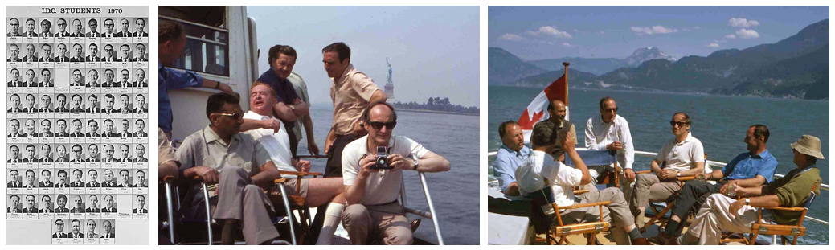
Alf’s IDC course photoboard (right) and on his Overseas Study Tour to Canada with the IDC (centre & right)
In treasured memory of his time at the IDC, Alf kept a copy of his course members’ photos in his pile of most precious personal documents until his untimely demise.
After completing the course, Alf moved just next door to Seaford House to serve as First Secretary & Head of the Political Department at the German Embassy. His claim to fame in this period stems from a prime-time German TV documentary about embassies, in which he charmingly described his daily duties as ‘dealing with many complicated matters, which sadly he’s not privy to disclose’. In this period he also caught the attention – and imagination – of a number of British tabloids.
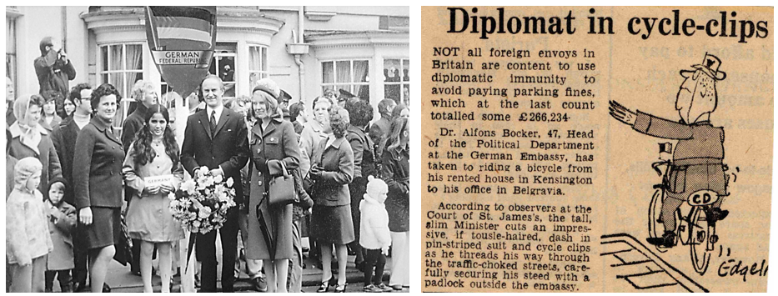
Daily Express; 16/08/1973
In 1975, Alf was transferred to Bonn, then capital of the Federal Republic of Germany, to lead the Middle East Department of the Foreign Office. These were turbulent times in the Middle East and Alf was thoroughly busy round the clock with little time for family or the yacht. During this time, Alf personally met nearly every relevant Arab, Palestinian, and Israeli leader, including Anwar Saddat, Hosni Mubarak, Menachim Begin, Moshe Dayan, Yigal Alon, and many others. He had to manage various dramatic scenarios including hijackings, kidnappings and attacks on embassies.
In 1978, Alf was unexpectedly moved back to the German Embassy in London, this time in the role of Chargé d’Affaires. While being provided a luxurious Embassy Flat in Prince’s Gate, Knightsbridge, (flat below Lady Churchill) the job involved an almost overwhelming schedule of representative tasks. Sailing up and down the Solent a few times in his beloved Contessa was the only timewise affordable escape.
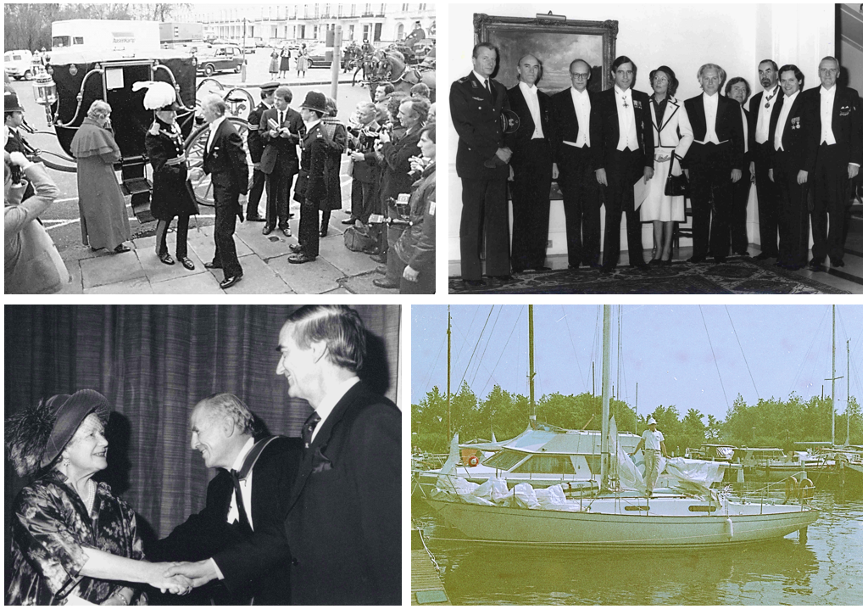
In 1980, Alf was posted to Brussels as deputy Ambassador to the German NATO Mission. The Ambassador, H.G. Wieck, a close friend, was absent for long spells preparing for a new role at the Foreign Office (and later to become President of the German Secret Service, Bundes Nachrichten Dienst, BND).
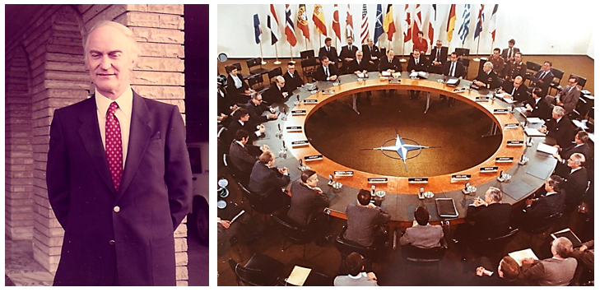
Dr A. Böcker (right side; four o’clock) representing FRG; 1981
Towards the end of 1982, Alf was appointed German Ambassador to Iraq, then at war with Ayatollah Khomeini’s Iran. My father, Klaus vividly remembers the sound of Iranian rockets at night during his one ‘home visit’. Well ahead of his time, Alf questioned the long-term wisdom of German construction companies building impenetrable command bunkers for the Iraqis. According to his notes, he also had to deal with allegations that German companies were providing the technology for the production of chemical weapons of mass destruction, deploying Tabun and N-Lost derivatives, as well as ‘old-fashioned chlorine’.
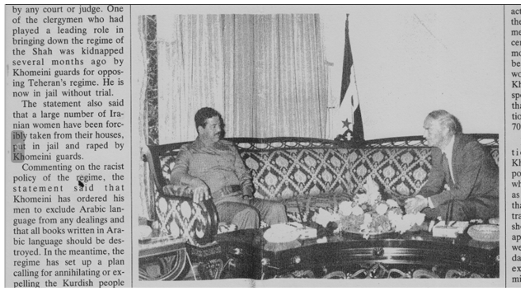
Meeting Saddam (long before his metamorphosis into the “Ace of Spades”); 1983
During his spell in Bagdad, Alf began to notice a pain in his hip, which he initially attributed to excessive activity on his exercise bike. When he started to feel a walking impairment he finally consulted a local Iraqi doctor, who bizarrely diagnosed a cold tuberculosis abscess. Sadly, on his return to Germany he was diagnosed with a highly malignant sarcoma. Alf opted for maximum treatment, including radical surgery, adjuvant chemo, and radiotherapy. In between treatments, Alf continued to work, flying out to Bagdad for odd weeks, and securing his transfer to a more suitable country, Norway, given his likely-terminal cancer diagnosis. Sadly, before the planned treatment could be completed the Sarcoma had relapsed, necessitating another surgical intervention. After this also ineffective surgical intervention, Alf’s condition rapidly deteriorated. He developed multiple metastases, including more than 50 x-ray-visible instances in his lungs, and passed away in Cologne University Hospital on July 18th, 1985, leaving behind his 51-year-old wife, Eva and his four children, the youngest, Eva-Elisabeth aged only 19 years.
Alf’s chief aspiration as a German diplomat was to try to repair the damage to the world caused by 12 years of brutal Nazi dictatorship both in his home country & abroad, explaining perseveringly that his generation of young Germans had essentially been victims of a profoundly evil system in which they were reared by their elders without opt-out options. He also wanted to show that Germans (now) unanimously wished to reunite and to play a trustworthy role in preserving peace and role-modelling disarmament (like his parents). Beyond that, Alf was a devoted, very liberal father, albeit not all too present on account of his workaholism, and passion for sailing with his eldest son, my father.
Until his death, Alf remained ‘one hundred percent certain that West and East Germany will be reunited, the Warsaw Pact will fall apart, and the Soviet Union will implode within his, or at least his children’s lifetime’. Sadly, Alf missed all three of these historic events by just a few years.

* * * * *

